Event Management – JS Push & Pop

Write a function for popping the details from the list of events and pushing the details to the list of events. Display custom messages during every push and pop function.

The push() method adds new items to the end of an array and returns the new length. The new items will be added at the end of the array. The pop() method removes the last element of an array and returns that element. Syntax : array.push(item1, item2, ..., itemX) array.pop()

Sample Screenshot  :  
  
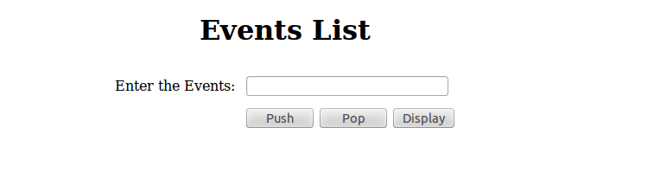  
  
Constraints : **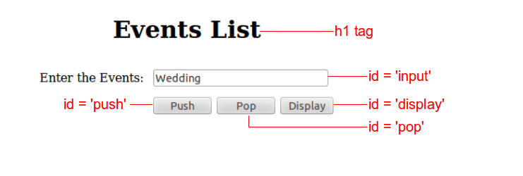  
  
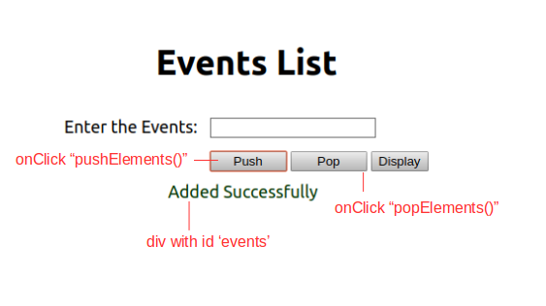  
  
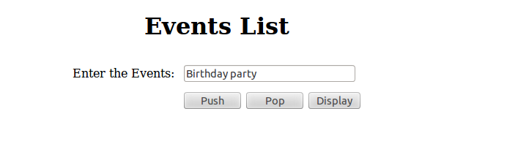  
  
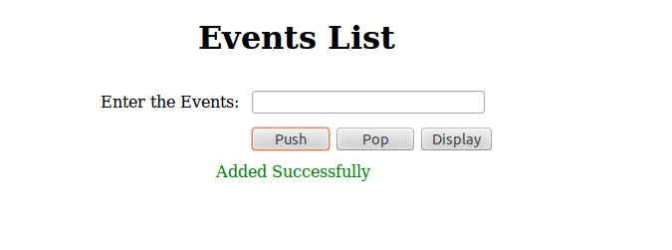  
  
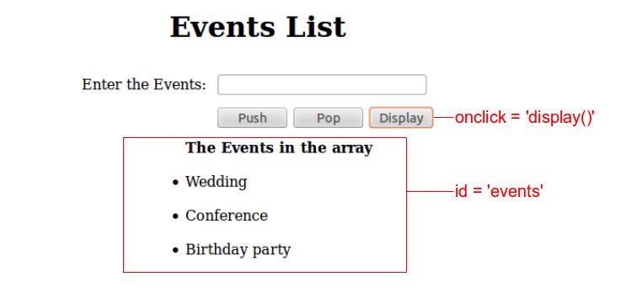  
  
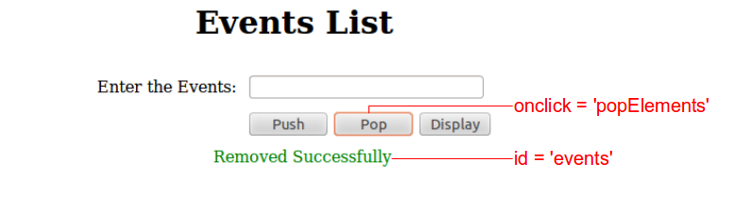  
  
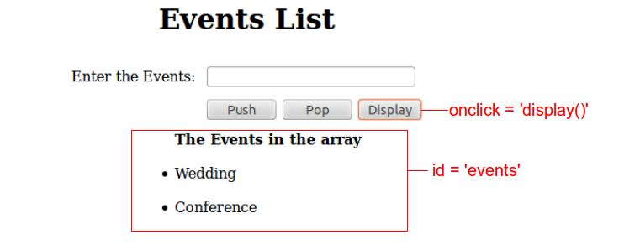**  
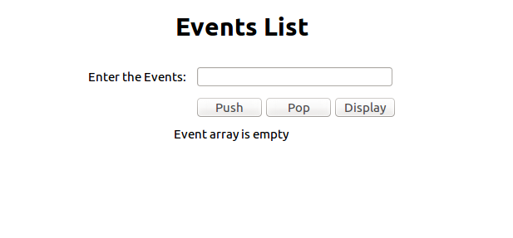  
  
Additional Constraints :  
  
Design the HTML page as given in the sample screenshot.  
Refer to the screenshot for id, tag, and function name specifications.  
  
Use **push()**and**pop()** method for adding and deleting the events in an array respectively.  
If there are currently no events in the array while clicking the display button, display the custom message 'Event array is empty'  
  
Note :  
  
Content of the page should be present as shown in the screenshot.  
Kindly refer to the content which is given as a part of the description